|  |  |  |  |
| --- | --- | --- | --- |
|  | | | |
| **CODE / COURSE** | **DFN40323- PROGRAMMING**  **ESSENTIALS IN PYTHON** | **PRACTICAL TASK** | **~~5~~** |
| **PROGRAM / CLASS** | **DDT4** | **DURATION** | **3 HOURS** |
| **STUDENT’S NAME** | 1. **SHELAN A/L PONNAN** 2. **MUHAMMAD AFIQ MUHAIMIN BIN MOHD ZAINI** | **CLO 1** | **P3** |
| **REG. NO.** | 1. **32DDT20F2001** 2. **32DDT20F2029** | **TOTAL MARKS** | **/40** |
| **LECTURER’S NAME** | **SHARIZAN BINTI ABDUL JAMIL** |

# Learning Outcome:

By the end of this practical, student will able to:

Construct a software application using the Python programming language (CLO1, P3, PLO3).

# Instructions:

Answer all the questions given. Students need to discuss in groups of two (2) and upload the findings of the discussion in report and .py file through CIDOS. Students will be accessed according to the Rubric given.

**Question 1**

By using Python codes,

1. Create a database name **Social Media Application**. The database will consist of four tables:
   1. **users** contain general information about users and has the following attributes:
      1. id
      2. name
      3. age
      4. gender
      5. nationality
   2. **likes** contain information about user who likes the posts and has the following attributes:
      1. id
2. user_id
3. post_id
4. **posts** contain information about posts and has the following attributes:
   1. id
   2. title
   3. description
   4. user_id
5. **comments** contain information about user who comments the posts and has the following attributes:
   1. id
   2. text
   3. user_id
   4. post_id

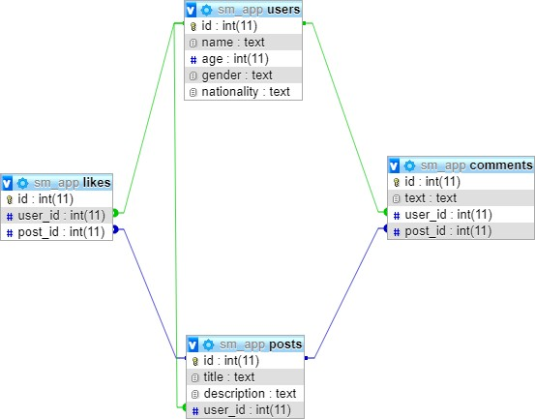fo

# Figure 1: Schema Diagram for Social Media Application

1. Add **FOUR (4)** suitable data into each table created.
2. View all data from each table using correct syntax.

# (25 marks)

**SOURCE CODE & OUTPUT:**

**createdb.py**

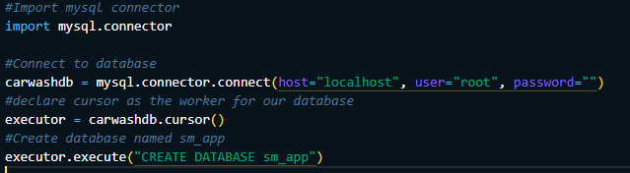



**createconn.py**

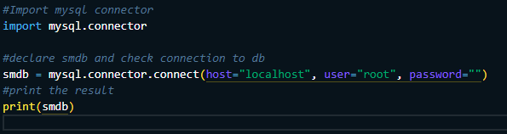



**users.py**

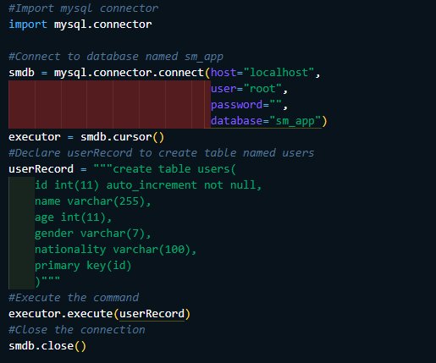

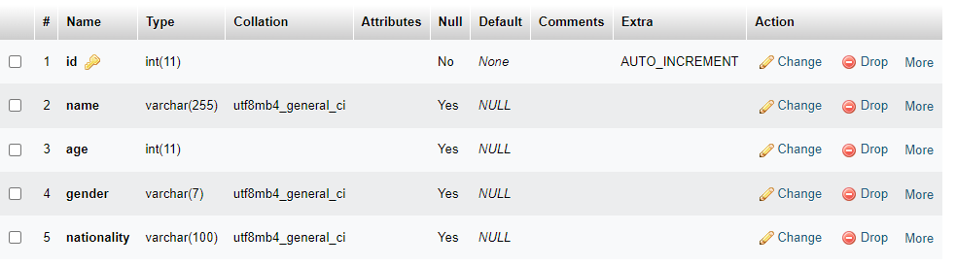

**posts.py**

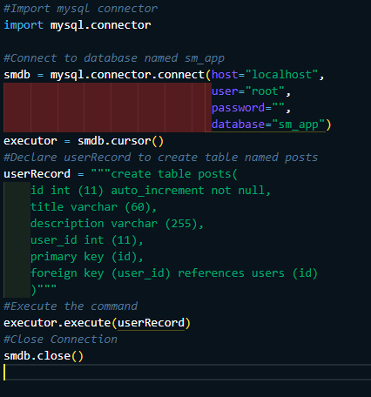

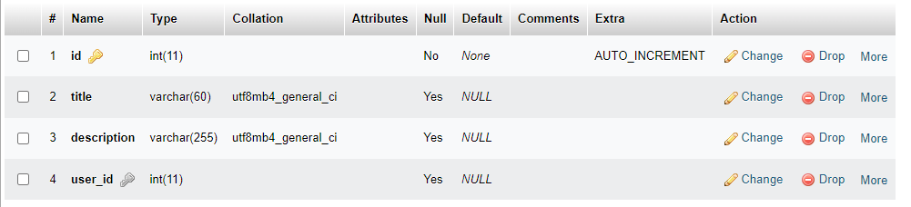

**likes.py**

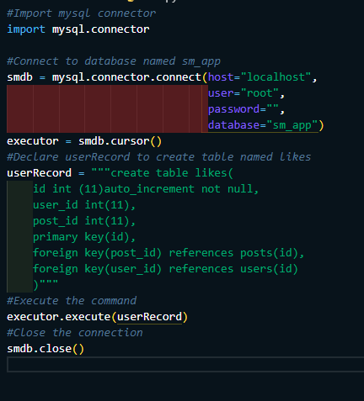

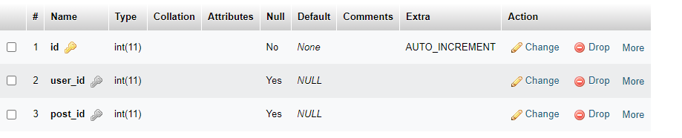

**comments.py**

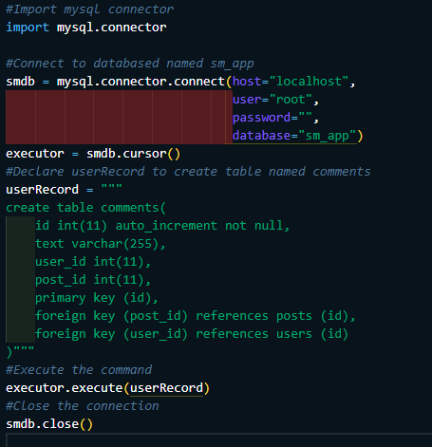

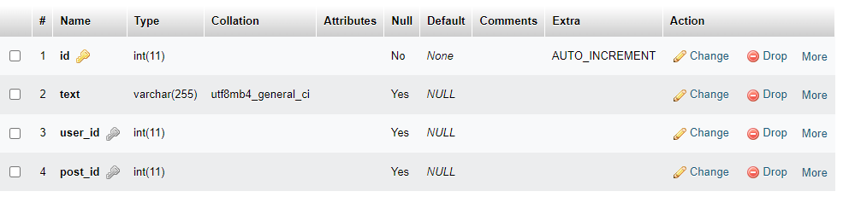

**insertuser.py**

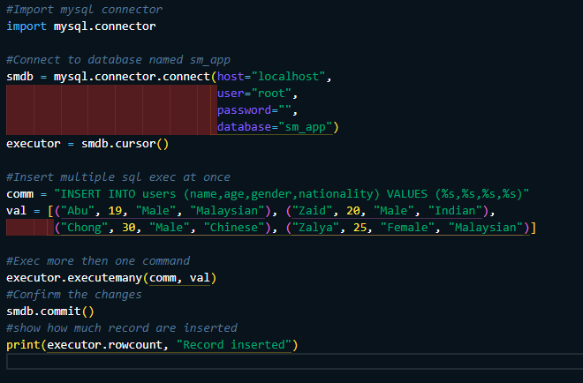



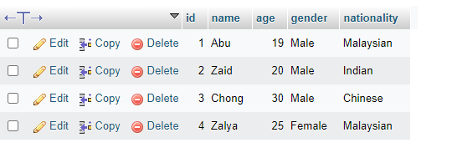

**insertposts.py**

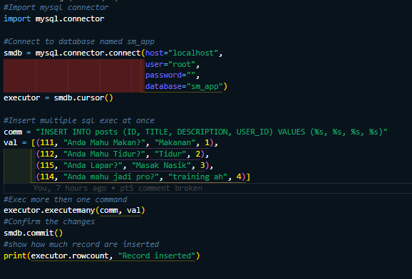



**insertcomments.py**

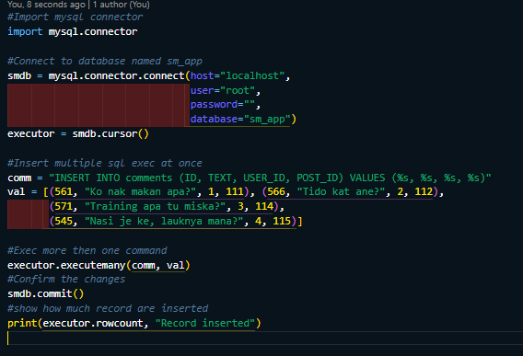



**insertlikes.py**

**Display data**

**displayusers.py**



**displayposts.py**



**displaycomments.py**



**displaylikes.py**



**Conclusion:**

**For conclusion, basically we learned on how to manipulate databases with python using multiple attributes that contribute to all of the databases feature and learn on how to insert data into db and learn on how to display all of the data in databases using the help of python**